Name(s) Cecilia Beckerbauer Period 4

|  |  |  |
| --- | --- | --- |
|  | **Worksheet - Video Guide for “IP Addresses and DNS”** | logo.png |

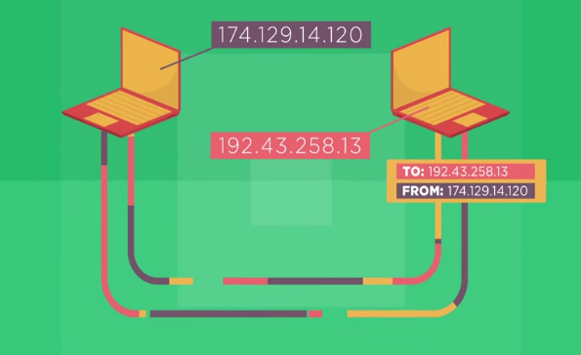

**Overview**

This video features the father of the Internet, Vint Cerf, and Microsoft engineer, Paolo Mejia, addressing the question, “How does data know where to go on the Internet?” They introduce the concepts of Internet Protocol (IP) addresses and the Domain Name System (DNS). In this worksheet, you will use ideas covered in the video as well as search for information on the Internet to answer questions… about the Internet!

**Directions**

1. Watch the video, “IP Addresses and DNS.”
2. Research any additional information required using an Internet search engine.

**Questions**

1. What is a protocol?  
   A well-known set of rules and standards used to communicate between machines.
2. What is an Internet Protocol (IP) address? How is it organized hierarchically?

The addressing system of the internet. It is organized with the first numbers representing the country/ network, followed by region/network, subnetwork, and the direct address.

1. How many bits are in an IPv4 address?  How many IPv4 addresses does that mean there are?

There are 32 bits each. There are more then 4 billion different IPv4 addresses out there.

1. What is the difference between IPv6 and IPv4.  Why do we need IPv6?

It has 128 bits compared to the original 32 bits. We need it because we need more addresses available.

1. What is an IP packet?

It is a series of information connected together that takes a path to get to their destination.

1. What is the difference between an IP address and an IP Packet?

An IP Packet is a series of information that goes to a computer. An IP address is the location of a website or other online domain that allows the computer to access it.

1. What is the purpose of the Domain Name System (DNS)?

It is to take you to your desired location on the internet.

1. How do you clear DNS cache?

You click the windows home button and type cmd.

1. Explain what DNS poisoning/ spoofing is doing and what are the dangers:

It is a type of attack that leads a computer from the intended location to a fake one. The computer will then store this and thus allows hackers access to your computer and if you give them the right information they can take your money.

|  |  |  |
| --- | --- | --- |
|  | **The Internet: Packets, Routing and Reliability** | logo.png |

1. How does a packet route to where it is going?

It has a destination address that takes it to the right device.

1. How does a router decide the cheapest possible route for packets?

It sends the packets along the fastest least congested direct route to their destination.

1. What is the function and process that TCP employs?

It handles communication between hosts and provides flow control, multiplexing, and reliability.